Original Operating Instructions

Gas Cooler Pury250 S

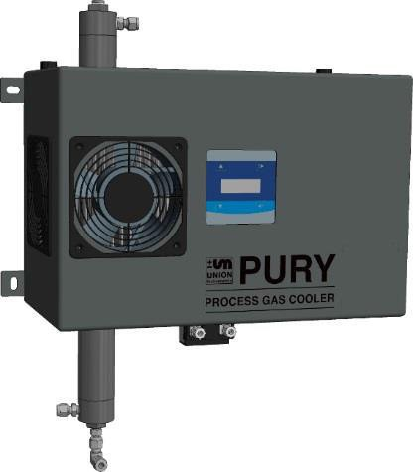

April-2016 V1.00

Union Instruments GmbH
Zeppelinstrasse 42
76185 Karlsruhe Germany
  +49 (0)721-680381-0
  +49 (0)721-680381-33
  support@union-instruments.com
 http://www.union-instruments.com

Article number: 03608199998
© 2016
This documentation is protected by copyright. All rights, in particular the rights of translation, reprint, extraction of figures, radio transmission, and duplication by photomechanical or other means and of storage in data processing systems, in whole or in part, are reserved.

Technical data subject to change.

Table of contents
- Technical data 5
  - Dimensions 5
  - Device parameters 6
  - Data and specifications 7
- EC Declaration of Conformity 9
- Safety information 11
  - Warning information and symbols 11
  - Principle, intended use 12
  - Personnel and qualification 12
  - Safety information 13
    - General safety information 13
    - Information on specific hazards 13
  - Recurring operator training 13
  - Performing a workplace hazard analysis 14
- Protective equipment 15
  - Housing cover 15
  - Markings and warning information 16
- Connections 17
  - General description 18
  - Accessories 18
- Transport, installation, and acceptance 19
  - Transport 19
  - Environmental conditions 20
6.2.1 Storage conditions 20
  - Installing and connecting 20
  - Installation location 20
    - Wall mounting 21
    - Process gas 23
    - Condensate line 25
    - Electrical connection 28
    - Electrical interfaces 28
    - Safety precautions on the owner side 31
  - Commissioning after installation 31
  - Documentation 31
- Commissioning/Switching on 33
- Description of the work stations/operator control elements 35
  - Work stations 35
- Operation 37
  - Description of display 38
    - Operation of membrane keyboard 38
    - Display area 39
  - Available displays 39
    - Menu structure 40
    - Navigation with keys Up ▲, Down ▼, ESC, and Enter 41
  - Menu for closed-loop control 41
    - Main menu 41
    - Target cooling temperature 41

11.2.1 Replacing filter inserts 50

Troubleshooting 55
  - Preparations 55
  - Changing/replacing fuses 56
  - Troubleshooting 56

Service 57

Related documents 59

Disposal 61

Spare parts 63

Appendix 65
Index 65
List of figures 66
List of tables 66

Technical data

Dimensions

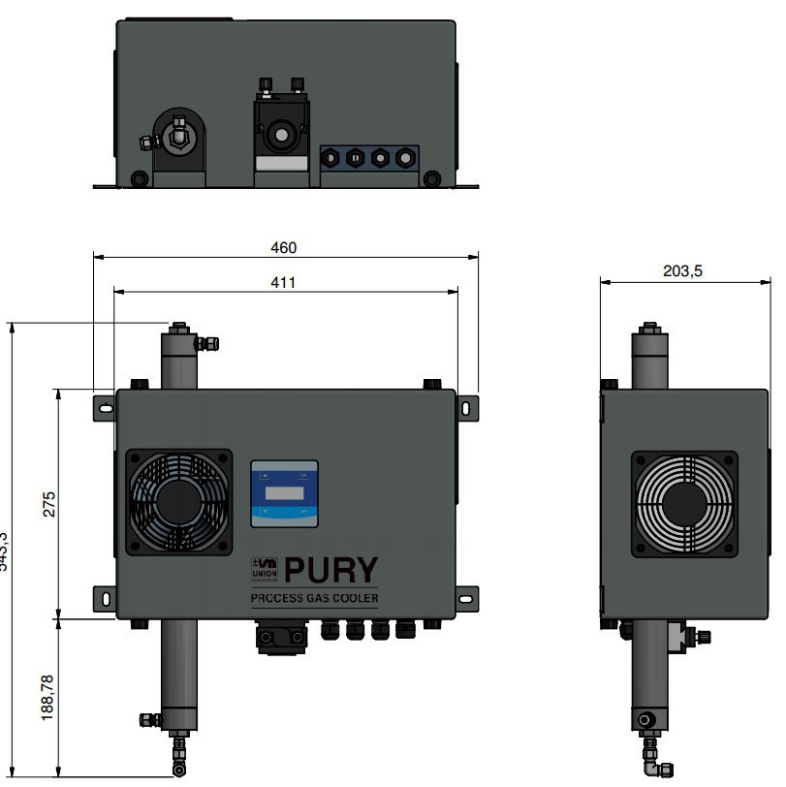

Weight approx. 12.6 kg

Device parameters

See device name plate and data and information accompanying the device. Example name plate:

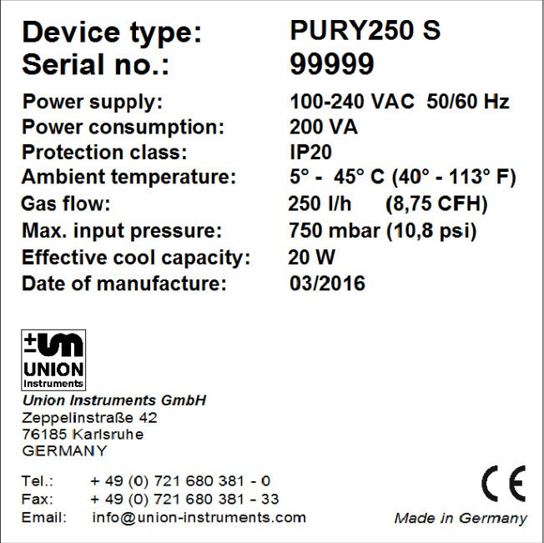
1

2

1

Fig. 1.1: Name plate (example)

    - Device description 2. Technical information

Technical data

  - Data and specifications Gas inputs
Input process gas: 1
Output process gas: 1
Output condensate: 1
Gas connections: Compression fitting 6 mm

Max. gas input pressure: 750 mbar absolute Min. gas input pressure: -100 mbar relative Gas pressure drop: 5 – 10 mbar

Relative gas humidity: < 95% (condensate-free)
Performance data
Gas capacity, max 250 l/h
Effective cooling capacity: 20 W at Δ T 25 °C

Gas temperature difference, max:
Max. 25 K

Protection class: I
Degree of protection: IP 22
Voltage supply
Voltage: 100 - 240 VAC 50-60 Hz
Power consumption: 250 VA max. Protection class: I
Degree of protection: IP22

Interfaces
Relays: 3

Environmental conditions
Operating temperature: 5 - 45 °C
Humidity: 0 - 95 % relative humidity Ambient pressure: 800 - 1100 hPa (0.8 – 1.1 bar)
Storage temperature: -20 – 60 °C

Weight

Weight: Approx. 12.6 kg

NOTICE
When the PURY250 S is used outside the environmental conditions, additional measures must be agreed with Union Instruments GmbH!

EC Declaration of Conformity

EC Declaration of Conformity

Der Hersteller / The manufacturer

Union Instruments GmbH Zeppelinstrasse 42
76185 Karlsruhe

erklärt hiermit, dass folgend bezeichnete Produkte / hereby declares, that following named products:

Produktbezeichnung: | Gaskühler | Gerätegruppe: PURY250
Product name | Gas Cooler | device group: PURY250

konform sind mit den Anforderungen, die in der EU – Richtlinie festgelegt sind / are compliant with the requirements as defined in the EU directives:
2014/35/EU Niederspannungsrichtlinie 2014/35/EU Low voltage directive
2014/30/EU Elektromagnetische Verträglichkeit 2014/30/EU Electromagnetic compatibility

Angewandte harmonisierte Normen / Used harmonized standards:

EN 61010-1:2010 Sicherheitsbestimmungen für elektrische Mess-, Steuer-, Regel- und Laborgeräte -
Teil 1: Allgemeine Anforderungen
Safety requirements for electrical equipment for measurement, control, and laboratory use - Part 1: General requirements
EN 61326-1:2013 Elektrische Mess-, Steuer-, Regel- und Laborgeräte - EMV-Anforderungen - Teil 1:
Allgemeine Anforderungen
Electrical equipment for measurement, control and laboratory use - EMC requirements - Part 1: General requirements

Name des Dokumentationsbevollmächtigten: Schlichter Name delegate of documentation
Adresse des Dokumentationsbevollmächtigten: siehe Adresse des Herstellers address delegate of documentation see address of manufacturer

Bei einer nicht autorisierten Änderung des Gerätes verliert diese Erklärung ihre Gültigkeit. / Any unauthorized modification of the device results in invalidity of this declaration.

Safety information

Warning information and symbols
The operating instructions use the following nomenclature and symbols for especially important information:

For an immediate danger that can lead to serious physical injury or death!
DANGER

For a potentially dangerous situation that can lead to serious physical injury or death!
WARNING

For a potentially dangerous situation that can lead to minor physical injury! This may also be used for warnings of property damage!
NOTICE

NOTE
For information that can improve the operation of the process gas analyzer or contribute to prevention of property damage.

Principle, intended use
The PURY gas cooler is used to dry and clean coke gas, blast furnace gas, and synthesis gas. It also provides a cleaning functions using stainless steel filter elements. Naphtalene crystallizes out in the moistened filters and is filtered with the condensate.

Application areas are the preparation of gases for further analysis with combustion calorimeters or process gas analyzers.

In the case of toxic or explosive gases, the safety provisions applicable at the installation location must be complied with.

The gas cooler is installed in a fixed manner and is intended only for use in closed rooms with adequate ventilation.

Any use beyond this is regarded as intended use. The manufacturer is not liable for damage resulting from this. In this case, the risk is borne solely by the installation engineer/commissioning engineer/owner/operator. Only certified experts are permitted to make changes to the gas cooler (mechanical/elec- trical/pneumatic changes).

WARNING
Intended use also includes observance of these operating instructions! In addition to the following safety information, the safety information of linked system components must also be observed!
Additional equipment or accessory parts not installed, supplied, or made by UNION Instruments GmbH require manufacturer's approval by UNION Instruments GmbH! Any warranty is otherwise voided!

Personnel and qualification
Gas connections and work on the electrical equipment of the gas cooler may only be carried out by a skilled person in compliance with safety provisions.

Safety information

Safety information

General safety information

Only operate the gas cooler when all protective equipment is present and operational!
Further safety information:
 Before the corresponding chapters!
WARNING

Information on specific hazards

- After installation, all gas-conveying parts must be checked for leak tightness according to national regulations.
- Any type of repair that requires opening of the protective cover may only be carried out by instructed personnel!
WARNING

Recurring operator training

NOTE
Country-specific regulations regarding recurring training of operators must be observed by the owner, particularly with regard to the handling of gases and electrical equipment.

Performing a workplace hazard analysis

NOTE
Depending on the national regulations and, if necessary, independent of the CE marking of the gas cooler, the owner must prepare a workplace hazard analysis!

Deviations from these operating instructions may occur due to further technical developments. If you desire additional information or if specific problems arise that are not covered in detail in this manual, you will receive information by contacting the following address:

Union Instruments GmbH
Zeppelinstrasse 42
76185 Karlsruhe Germany
  +49 (0)721-680381-0
  +49 (0)721-680381-33
  support@union-instruments.com
 http://www.union-instruments.com

Protective equipment

Housing cover

Fig. 4.1: Housing cover

Protective equipment

Markings and warning information

1

Fig. 4.2: Markings and warning information

    - Name plate

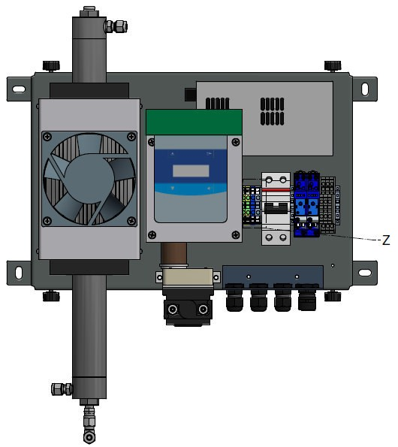
2

Fig. 4.3: Warning in the housing

    - 230 V voltage

Connections

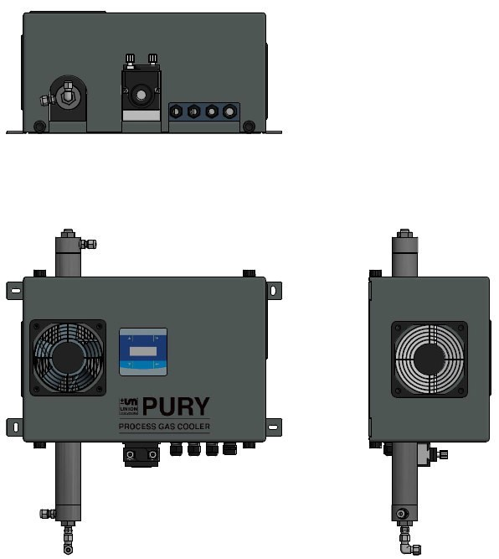
12
1 13
11
1
13
9
2
2
10
13
6
4
5
3
8
7
Fig. 5.1: Product description

- Housing screws, 4 pieces 8. Eingang Prozess Gas Input process gas
- Side fans, left, right 9. Display with operator input keys
- Cooler tube with filter 10. Front fan

- Condensate pump inlet side suction from gas cooler
- Ausgang Prozess Gas Output process gas

  - Condensate pump 12. Cable bushings, voltage supply

  - Condensate pump discharge side pressure
output condensate
  - Ausgang Kondensat Output condensate
13. Wall mounting, 4 pieces

Connections

General description

Accessories

WARNING
Risk of injury/damage!
The use of non-approved accessories may cause damage and endanger persons. Any warranty is voided in this case. The owner is then liable for damage that occurs!
Only use genuine accessories or accessories approved by Union Instruments GmbH.

Transport, installation, and acceptance

NOTE
The gas cooler is generally commissioned by Union Instruments GmbH or service technicians.
When it is not transported, installed, and commissioned by Union Instruments GmbH (e.g., internal transport/resale), the suitable procedure must be agreed with Union Instruments GmbH ( Chapter 12 Service).

Transport

Tipping over or dropping of the gas cooler from the pallet or load carrying means may cause injuries!

- For the unpacking and transporting, observe the weight and dimensions (see technical data)!
Use a second person or aid if required.
WARNING

NOTE
In case of transport damage that is indicative of improper handling, a damage assessment by the transport carrier (rail, mail, shipping company) must be arranged.

Environmental conditions

NOTICE
Comply with environmental conditions for storage and installation!
Comply with environmental conditions! Contact Union Instruments GmbH if the gas cooler is stored for longer than 3 months or must be operated or stored outside the prescribed environmental conditions!

6.2.1 Storage conditions

Ambient temperature: -15 – 60°C
Air humidity: 0 - 95% relative humidity Ambient pressure: 700 – 1400 hPa (0.7 – 1.4 bar)

Frozen condensate water in the gas cooler may cause damage. Empty and dry the gas cooler before storing it!

Installing and connecting

Installation location
The installation location of the gas cooler must meet the following conditions:

    - Clean dry room
    - Protect from climatic influences, if necessary, with heating and cooling
    - Ensure adequate load carrying capacity of the wall, the device must be installed on a fixed wall

WARNING

Escaping process gas may pose a hazard!
Perform a leak test after installation and after work on gas-carrying lines!

Wall mounting
The gas cooler is intended to be wall-mounted. The wall brackets are integrated on the housing.

The wall used for mounting must be sufficiently sturdy to bear the weight of the gas cooler.

Secure the gas cooler to a fixed wall at all mounting points.

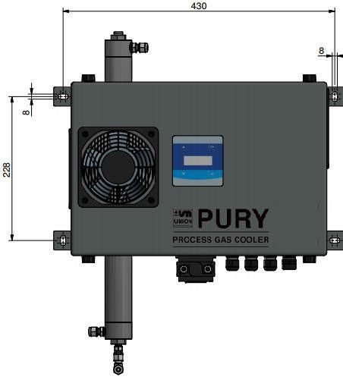
Fig. 6.1: Wall mounting

Provide adequate room for maintenance purposes. Filter element is removed upwards for maintenance, housing cover is removed downwards.

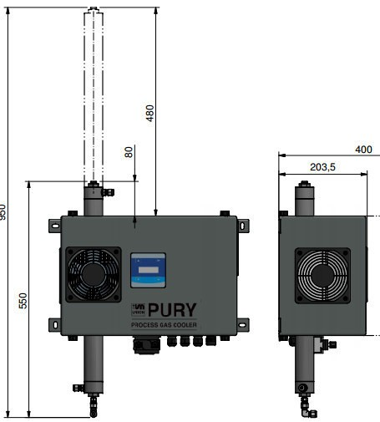
Fig. 6.2: Minimum installation space

Process gas

NOTE
- Connection parts must be clean and free of residues.
- The input pressure for the gas connections must not exceed the specifications of the information sticker on the gas cooler.
- Each connection point must be carefully checked for leak tightness. Escaping gas may pose hazards!
- Do not use sealing paste for sealing the gas connections. Sealing paste ingredients may falsify the measurement result of subsequent analyses. Use PTFE-sealing tape.
- Only suitable lines may be used.
- Ensure frost-proof discharge of condensate via a separate line.

Connection of process gas
Compression fittings 6 mm are intended for the connection.

The upper part/lower part can be positioned in four directions – this allows a suitable position to be found for the input/output process gas.

Gas discharge!
Connection of gas connections by qualified personnel only!
Observe the installation instructions of the compression fittings, installation by trained personnel only!
Check gas connections for leak tightness!
WARNING

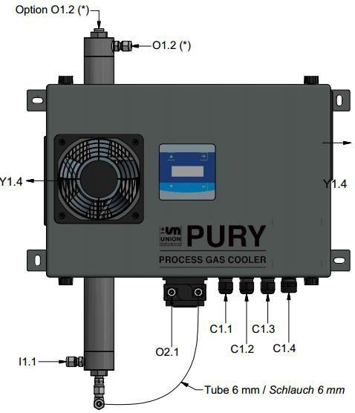
Fig. 6.3: Connection of input/output process gas

Item No. | Designation
I1.1 | Eingang Prozessgas / Input Process Gas, max. 0,75 bar
O1.2 | Ausgang Prozessgas / Output Process Gas, discharge without pressure
(*) | If required, the male coupling "O1.2" and the closure plug "Option O1.2" can be swapped.
O2.1 | Ausgang Kondensat / Output Condensate

Condensate line

NOTE
- Route hose so as to avoid blockages and in a downward sloping manner.
- Install output condensate in a frost-proof manner!
- Discharge condensate without pressure!
- A ventilated container is recommended – inspect/clean regularly.

Installation of condensate line
Compression fittings 6mm are intended for the connection.

Discharge of condensate!
Connection by qualified personnel only!
Observe the installation instructions of the compression fittings, installation by trained personnel only!
WARNING

Inspect and, if necessary, join together the hose and compression fittings.

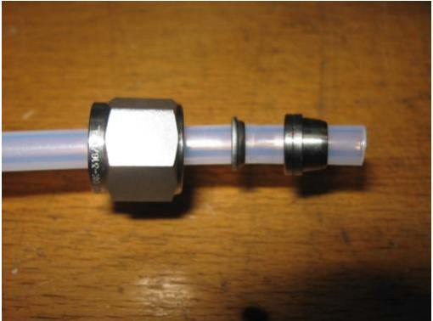
Fig. 6.4: Hose with clamping ring

Make the connection between gas cooler and pump.
Insert hose into screw fitting on the output condensate and install compression fitting according to instructions.

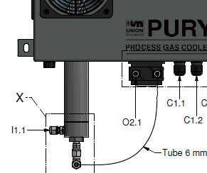
Fig. 6.5: Output condensate

Insert condensate hose onto suction side of the pump and install compression fitting according to instructions.

Fig. 6.6: Screw fitting of pump

View after installation is complete
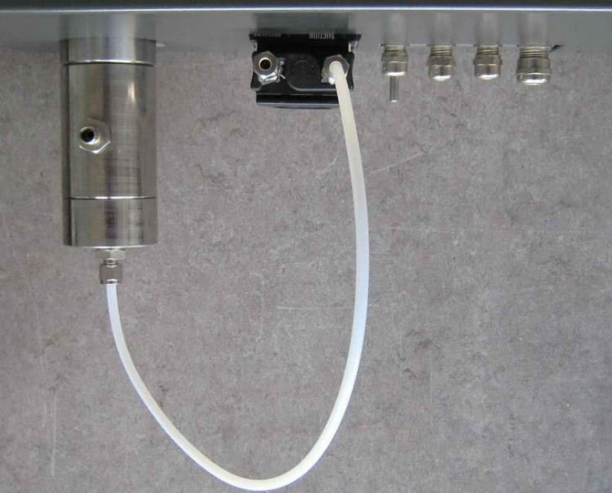
Fig. 6.7: Condensate hose after installation

Connect hose for the condensate discharge to the pressure side of the pump. Use compression fitting according to instructions.

Electrical connection

DANGER
Danger of electric shock!
Changes to the electrical equipment of the gas cooler may be carried out only by skilled electricians in accordance with electrotechnical rules.
Parts of the open gas cooler marked with the adjacent symbol may still carry voltage even when the main switch is switched off! If required, disconnect the gas cooler from the supply network!

Electrical interfaces

WARNING

Endangerment of people and equipment when the gas cooler is commissioned by non-instructed personnel!
Allow only instructed/trained service technicians to carry out commissioning!

Connection of voltage supply

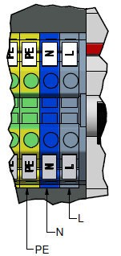
Fig. 6.8: Voltage supply

Connect the gas cooler to the voltage supply using connections L1, N, PE in accordance with national requirements.

Ground fault circuit interrupter and back-up fuse (16 A) required for L and N connections.

Remove housing cover, 4 screws on top and bottom of housing.

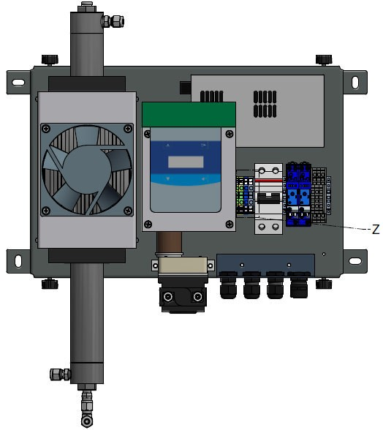
Fig. 6.9: Access to voltage supply connections

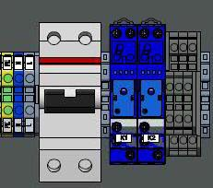
Electrical interfaces Relays

Fig. 6.10: Relays: K1 – K2

Designation | Function
Relay K1 | Signal that dew point is reached. The CWD2005 calorimeter will not start until the dew point temperature is reached. Use as a control signal also possible.
Relay K2 | Monitoring of difference between gas cooler temperature and room temperature. Room temperature (temperature at the calorimeter) must be greater than at the gas cooler.

NOTE
Operate relays with functional extra-low voltage only! Do not connect to line voltage!

Maximum load of relay connections 30 VDC / 1 A.

Safety precautions on the owner side

- The owner must provide suitable protective equipment for the gas cooler that can reliably prevent injuries to personnel, e.g., from escaping gas!
- Mark outlet location of discharged condensate with a warning!
- Tripping hazard from improperly routed supply lines!
WARNING

Route supply lines in a suitable manner.

Commissioning after installation

Endangerment of people and equipment when the gas cooler is commissioned by non-instructed personnel!
Allow only instructed/trained service technicians to carry out commissioning!
WARNING

Documentation

NOTE
Union Instruments GmbH recommends keeping a maintenance manual and documenting all work and tests.
Union Instruments GmbH recommends documenting the proper installation and commissioning.

Commissioning/Switching on

In order to establish start readiness, also establish the start readiness of linked system components according to their operating instructions!
NOTICE

NOTE
The following table contains significantly shortened steps for commissioning after an extended downtime.

To switch on the gas cooler again after a short shutdown, some steps can be omitted:
 Right column!

Steps | Commission- ing | Switching- on
Check whether environmental conditions meet the requirements ( page 7, section Technical data!) . | X | X
Check whether the gas cooler is securely mounted. | X
Check whether the device is suitable for the process gas. | X
Check whether the gas connections are correct and leak-tight. | X | X
Check whether the condensate connections are correct and leak- tight. | X | X
Furnish/switch on owner-side energy supplies and media supply. | X | X
Ensure voltage. | X
Open the shut-off valves. | X | X
Switch on the voltage supply of the gas cooler. | X | X
Establish start readiness of linked system components. | X | X
When the gas cooler has been switched off only temporarily, production can be resumed!

Description of the work stations/operator control elements

NOTE
This chapter contains only elements for operation of the gas cooler by the normal operator.

  - Work stations

1
Fig. 8.1: Work stations

Item No. | Designation | Function/Activity
1 | Display | Display status.

Operation

WARNING
Risk of injury!
Only operate the gas cooler when all lines are installed and have been checked for leak tightness in accordance with country-specific regulations.

Description of display

Operation of membrane keyboard
The software controller is operated using a membrane keyboard. The buttons shown can be selected by a keypress The menu structures are deliberately kept flat so that functions can be accessed quickly.

NOTICE
Damage to membrane keyboard!
Operation with objects other than fingers may damage the membrane keyboard!

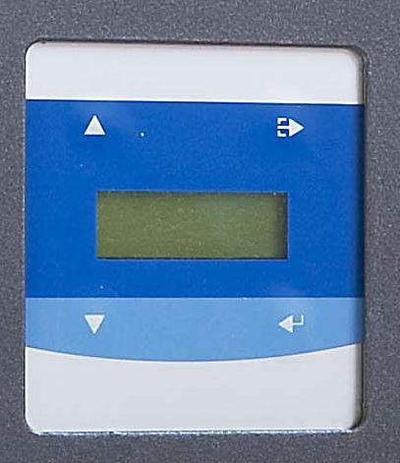

1

2

5

4

3
Fig. 9.1: Operator control elements

Item No. | Designation | Function
1, 4 | Change value | The displayed values are changed with the keys.
2 | Menu key | Navigation through menu structure, moves one level up, Back/ESC
3 | Menu key | Navigation through menu structure, moves one level down, Next

Display area

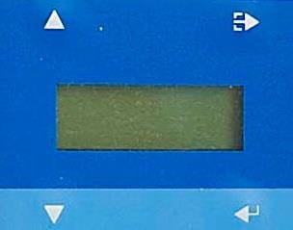
1
Cool 3.0°C
Amb 25.0 °C
Fig. 9.2: Display

Item No. | Designation | Function
1 | Display | Display of status information, measured values, here cooler temperature 3°C  ambient temperature 25°C

9.2 Available displays

NOTE
The available displays and their function are described below. The displays are accessed using the menu and function keys shown in the chapter headings.

The structure shown below forms the basis of the controller.

Menu structure

NOTE
Some of the red-framed menu items may affect the function after a change.

Main menu
Setpoint Target cooler value
Setpoint EXT Threshold value for external cooler Diff Ambient Minimum difference for external cooler Pump Amount Condensate flow rate of pump

Main menu Back/ESC Hold key 5 seconds Password Service Mode
NTC0Offs Temperature sensor cooling block NTC1Offs Temperature sensor outside temperature OP-Window Operating range
T / PWM Cooler / Controller

The red-framed menu items are only required after maintenance/repair and replacement of spare parts.

Navigation with keys Up ▲, Down ▼, ESC, and Enter

      - Values are changed with the
▼▲ keys
      - Navigation between the displays/menus with the "Next" and "ESC" keys.

Menu for closed-loop control

Main menu

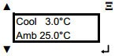
Display of cooler temperature and ambient temperature.
↵ key takes you to the next menu

Target cooling temperature

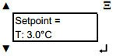
Display and setting of the target temperature of the cooler. Default value is 3°C, setting range: 2°C to 25°C.

Switching temperature of fan

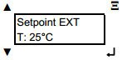
Display and setting of the switching temperature of the fan. Default value is 25°C, setting range: 25°C to 50°C.

    - Difference between ambient and cooler temperatures

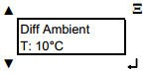
Difference is a measure for the degree of drying. Default value is 10°C, setting range is "Off", 10°C to 30°C.
"Off" means that no temperature difference is permitted. Cooling to the dew point temperature will be carried out.

    - Pump condensate quantity

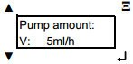
Information on the expected condensate quantity, pump delivers this quantity automatically at intervals.
Default value is 5 ml/h, setting range is 5 ml/h to 150 ml/h.
Note: The service life of the condensate pump is dependent on the flow rate. Adjust the condensate quantity to the conditions.

condensate ml/h
40,00

35,00

30,00

25,00

20,00

15,00

10,00

5,00

0,00
5 10 15 20 25 30 35 40 45 50 55 60
gas temperature

Table 1: Condensate quantity

Condensate quantity for: Dew point 5°C and 250 liter gas saturated 100 mbar gauge pressure.

  - Menu for service settings

NOTE
Disturbance of function!
When the following parameters are changed, the function of the device may be affected.
Allow only authorized persons to make changes!

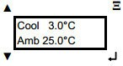

From the main menu – Display of cooler temperature/ambient temperature - hold down the ESC key for 5 seconds.

The following settings are only required after maintenance/repair and replacement of spare parts.

    - Password for service mode

If the password is forgotten, changes to the configuration are no longer possible!
NOTICE

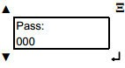

Assignment of a password for service mode. Default value is 042, setting range is 000 to 999.
Set password with ▼▲ keys, when the arrow key is held down, the counter counts
in increments of 10.

    - Temperature sensor cooler

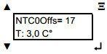
Display and setting of the offset of the temperature sensor. Corrects the temperature by the corresponding value. Default value is +99, setting range is -99 to +99.

Display and setting of the offset of the temperature sensor. Corrects the temperature by the corresponding value. Default value is +99, setting range is -99 to +99.

9.4.4 Operation Window
Display and setting of the operating range Default value is 2°C, setting range: 2°C to 10°C.

- Decommissioning / Switching off

In order to decommission the gas cooler, also decommission the linked system components according to their operating instructions!
NOTICE

NOTE
The following table contains steps for decommissioning for an extended downtime.
To switch off the gas cooler only temporarily, some steps can be omitted:
 Switching off column!

Risk of serious injury from escaping gases!
- Gas and condensate residues may be harmful to health.
- Gas connections may only be made by skilled personnel.
- Guidelines applicable at the installation location must be observed.
WARNING

Decommissioning / Switching off

Steps | Switching off | De- commissi oning
Disconnect the device from the process, professionally close the line. | X | X
Flush gas cooler with ambient air. |  | X
Bring linked system components to a standstill. | X | X
Clean cooler, see maintenance instructions |  | X
Switch off voltage supply | X | X
If the gas cooler is to be taken out of service only temporarily, the process ends here!
Professionally disconnect/switch off owner-side energy supplies, media supply, and signal transmission. |  | X
When appropriate, pack the gas cooler in a suitable manner. |  | X

- Maintenance
The function of the gas cooler can only be guaranteed when the maintenance intervals are adhered to.

  - Preparations

Supply lines of linked system components can be closed for maintenance purposes. These must be reopened after the device is put back into service.

Risk of serious injury from electricity!
- Parts of the gas cooler with the adjacent symbol may still carry voltage even when the main switch is switched off! If required, disconnect the gas cooler from the supply network!
- Switch off main fuse and, if necessary, secure against switch-on.
- Only skilled electricians are permitted to work on the electrical equipment of the gas cooler!
DANGER

Risk of serious injury from escaping gases!
- Before carrying out maintenance work on the gas cooler and whenever necessary, also bring the linked system components to a standstill!
- Gas connections may only be made by skilled personnel. Guidelines applicable at the installation location must be observed.
- Check gas connections for leak tightness!
WARNING

  - Maintenance work/Inspection

NOTE
Maintenance work must be performed according to the inspection and maintenance schedule! The nature and amount of wear depends greatly on the individual use and operating conditions. All specified intervals are therefore guide values.

Check | Interval (recommended)

Weekly check
Output condensate is free (especially from frost) | Weekly

Semi-annual check
Function of condensate pump | Every 6 months
Check fan for dirt. | Every 6 months | Or as required
Replace fan filter mat if necessary | Every 6 months
Pump hose | Every 6 months
Check filter inserts and, if necessary, replace | Every 6 months | As required depending on the process gas
Check track rollers of the condensate pump for pump hose. | Every 6 months

Maintenance/component replacement | Interval (recommended)

As required and based on degree of soiling
Replacement of filter inserts | As required, based on operating conditions

Annual service
Replacement of pump hose | Annually, | more frequently as required
Impeller | Annually

As required
Replace condensate pumps | As required

PTFE hoses (connections) | As required

    - Replacing filter inserts

Disassembly

To replace the filter inserts, the cooler tube must be removed.

      - Unscrew compression fittings of the input process gas and output process gas.

      - Unscrew compression fitting of condensate hose on cooler tube.

      - Screw off lower part from the tube.

      - Pull out tube upwards from the cooler.

      - Screw off upper part from the tube.

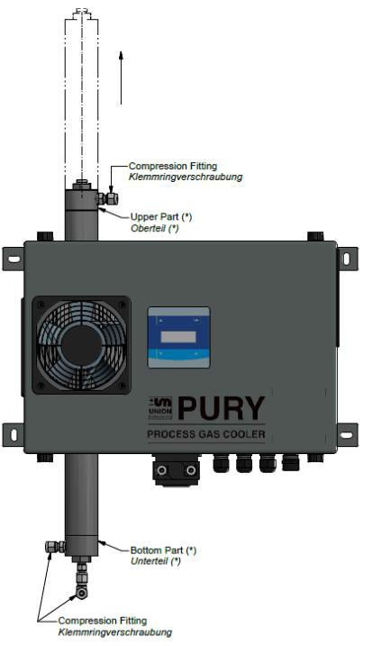
4
5
1
3
1
2
Fig. 11.1: Disassembly of cooler tube

Replacing the wire filter inserts

        - Screw off wire filter inserts downwards from the tube. Observe the correct order, two different types are used.
Filter inserts can also be pulled out downwards with a suitable tool.

        - Insert new filters in the correct order, ensure a secure fit!

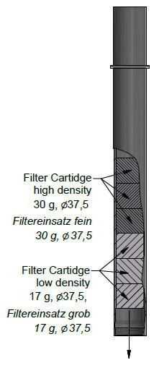
Fig. 11.2: Replacing the filter insert

Assembly

- Clean or replace the O-rings for the upper and lower parts.

- Insert wire filter inserts in tube.

- Assembly in reverse order.

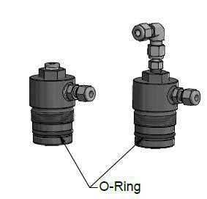
Fig. 11.3: O-rings of upper/lower parts

- Troubleshooting

NOTE
The function of the UNION calorimeter connected to the gas cooler may be disturbed by the reaching of a readiness condition.
Problems in the gas cooler may negatively affect the cleaning and cooling functions and subsequent analyses.

  - Preparations
Supply lines of linked system components can be closed for maintenance purposes. These must be reopened after the device is put back into service.

Risk of serious injury from electricity and escaping gases!
- Before carrying out maintenance work on the gas cooler and whenever necessary, also bring the linked system components to a standstill!
- Switch off main fuse and, if necessary, secure against switch-on.
- Only skilled electricians are permitted to work on the electrical equipment of the gas cooler!
- Parts of the gas cooler with the adjacent symbol may still carry voltage even when the main switch is switched off!
- If required, disconnect the gas cooler from the supply network!
WARNING

Troubleshooting

  - Changing/replacing fuses
Only skilled electricians or service technicians are permitted to replace fuses. Only replace with fuse types specified by UNION.

  - Troubleshooting

no. | Description
1 | Cooler/fan does not start up.  - A check must be made to determine whether the device is properly connected to the power supply system.  - The Pury does not activate the calorimeter. The ambient temperature is too high. Switch the additional readiness condition Diff Ambient to "off" or set a smaller value.
2 | Device does not cool.  - The filter is dirty and must be cleaned.  - The fan is not delivering enough cooling air. Check fan.
3 | Condensate is escaping from the output.  The filter is filled with condensate. Inadequate condensate suction.  - Check pump hose for free passage.  - Increase the switching frequency of the condensate pump.  - The flow rate of the gas is too high. Check whether flow rate exceeds 250 l/h, reduce flow rate.

- Service

NOTE
Union Instruments GmbH is available to answer any questions.
In case of orders or technical questions, please provide your customer number, phone number where you can be reached, the gas cooler type and number (see name plate), and required spare parts/bills of material numbers, if applicable.

Union Instruments GmbH - Service
Maria-Goeppert-Straße 22
23652 Lübeck Germany
 +49 (0)721-680381-30
 support@union-instruments.com
 http://www.union-instruments.com

Service

- Related documents

- Declaration of Conformity
- Service documentation, optional

- Disposal
Following decommissioning, take back of the device by Union Instruments GmbH is possible.

Suggestion: Have Union Instruments GmbH dispose of your gas cooler.

Risk of injury from electricity and, if applicable, gases in the process gas analyzer!
WARNING

Before removal, disconnect gas cooler from energy supplies! Flush out gases, clean filter!

NOTE
Observe national regulations for disposal of machines and working materials. Sort parts by groups and supply them to professional recyclers.

- Spare parts

Use of non-approved spare parts (e.g., parts of other manufacturers, parts with deviating specifications, imitation consumables and wear parts) may cause damage and endanger people! Any warranty is voided in this case. The owner is- then liable for damage that occurs!
When standard components are replaced, use only identical components of the original manufacturer! In the event that components are discontinued or components of other manufacturers are used, this requires manufacturer's approval by UNION Instruments GmbH!
WARNING

Spare parts can be ordered from Union Instruments GmbH:
 Chapter 12 Service.

Make a note of the gas cooler type and serial number ( Name plate).
Identify and make a note of the order number, if applicable ( Included documents).
Order part.

- Appendix

Index

A
Accessories 20

C
Commissioning 35
Condensate line 27
Connecting the process gas cooler 22
Connections 19
Contact
Service 59
UNION Instruments GmbH 14

D
Decommissioning ............................47, 63 Display 41
Displays 41
Disposal 63

E
EC Declaration of Conformity 9
Electrical connection 30
Relays 32

Voltage supply 31
Electrical interfaces 30
Environmental conditions 22

F
Fault correction 57

H
Housing cover 15

I
Inspection 50
Installation location 22
Installing the process gas cooler 22
Intended use 12

M
Maintenance 49
Maintenance work 50

N
Navigation with arrow keys 43

O
Operation 39
Operation of membrane keyboard 40
Operator control elements 37
Operator input with keys 43

P
Personnel and qualification 12
Process gas 25
Protective equipment 15

S
Safety information ........................... 11, 13
Service 59
Spare parts 65
Symbols 11

T
Transport 21
Troubleshooting 57

W
Wall mounting 23
Warning information 11

Work stations 37

Appendix

List of figures
Fig. 1.1: Name plate (example) 6
Fig. 4.1: Housing cover 15
Fig. 4.2: Markings and warning information 16
Fig. 4.3: Warning in the housing 16
Fig. 5.1: Product description 17
Fig. 6.1: Wall mounting 21
Fig. 6.2: Minimum installation space 22
Fig. 6.3: Connection of input/output process gas 24
Fig. 6.4: Hose with clamping ring 25
Fig. 6.5: Output condensate 26
Fig. 6.6: Screw fitting of pump 26
Fig. 6.7: Condensate hose after installation 27
Fig. 6.8: Voltage supply 29
Fig. 6.9: Access to voltage supply connections 29
Fig. 6.10: Relays: K1 – K2 30
Fig. 8.1: Work stations 35
Fig. 9.1: Operator control elements 38
Fig. 9.2: Display 39
Fig. 11.1: Disassembly of cooler tube 50
Fig. 11.2: Replacing the filter insert 51
Fig. 11.3: O-rings of upper/lower parts 52

List of tables
Table 1: Condensate quantity 42

